**Instructions for my application**

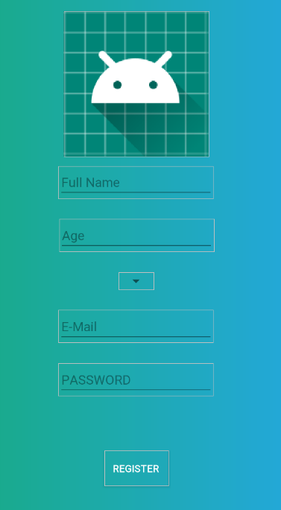

1. This is the signup page where you would need to signup before you can login to the app

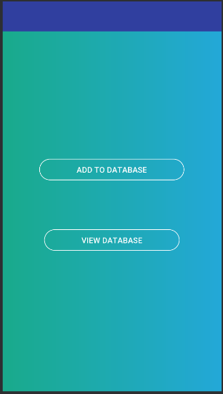

1. This is the home page of the app and you would be able to add data straight to the database or you can view the data. I have also made a menu bar on the top right of the screen where you can either logout, View profile or Refresh the page.



1. This the View Data page where you will be able to see the data that has been added onto the database. There is also an add button where you have the option to add to the database. Data would be shown whenever data is added and you would be able to click on the data and either update the data or delete it from the database.

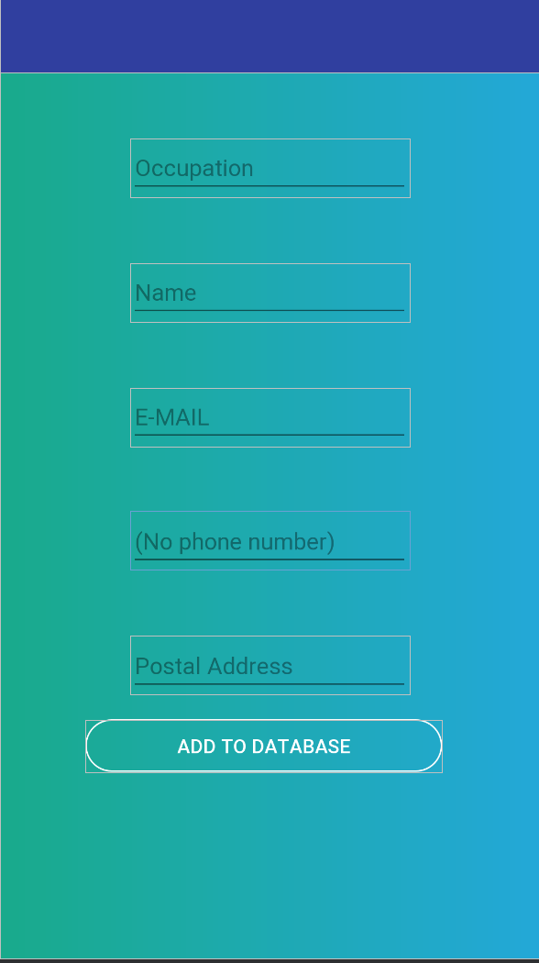

1. This is where you will be able to add data onto the database

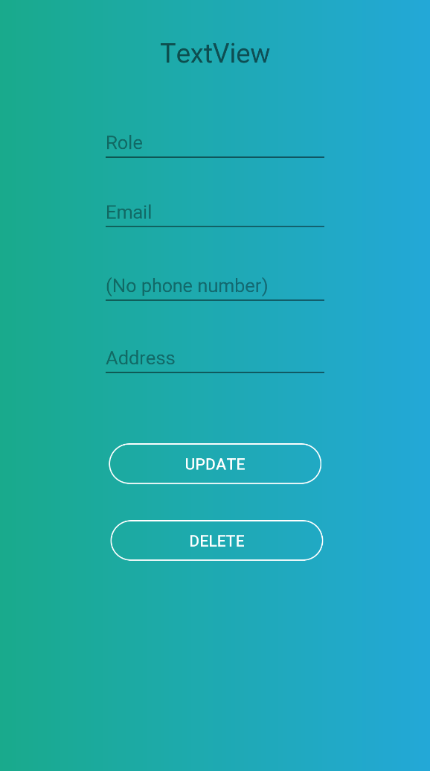

1. This is the update or delete page where you will be able to update the data that has been entered or delete it from the database.

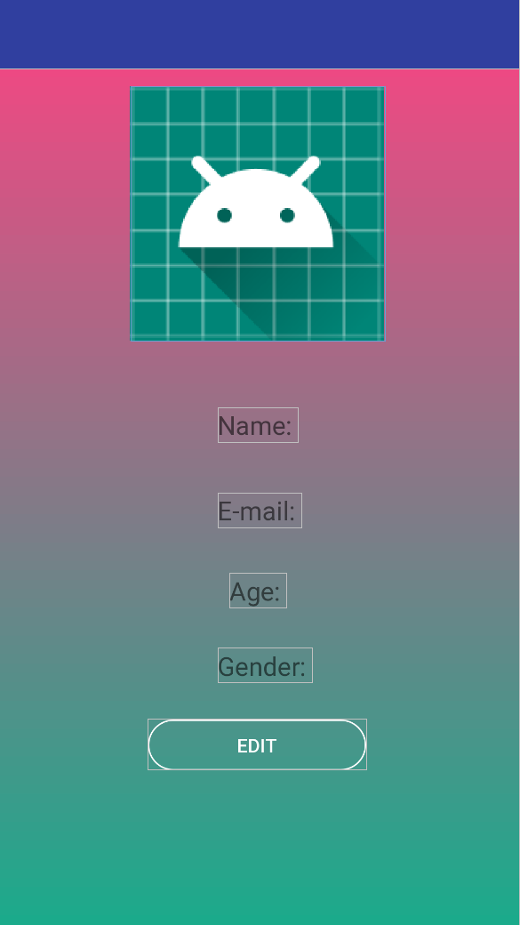

1. This is the Profile page where you can see your info when you first signed up and you are also able to edit the information if you need to

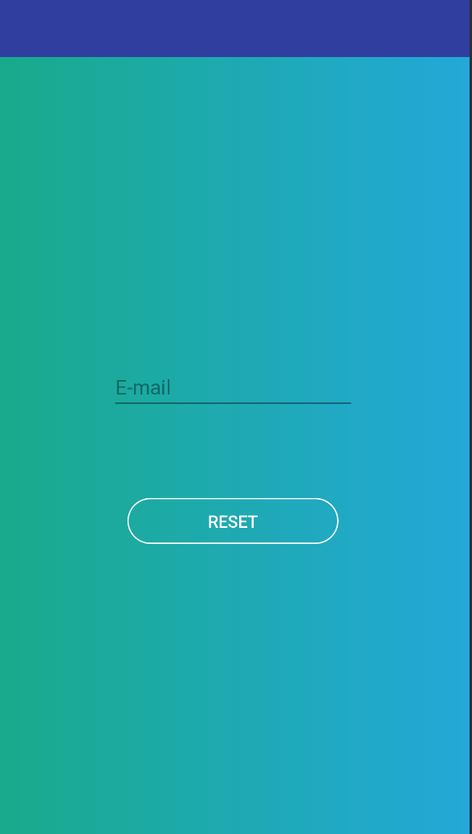

1. This is the forgotten password page where you are able to find when trying to login and from here you would just need to enter a valid email and an email would be sent out so you can reset your password.